**Summary**

**Dashboard - 1**

**Visualization - 1**

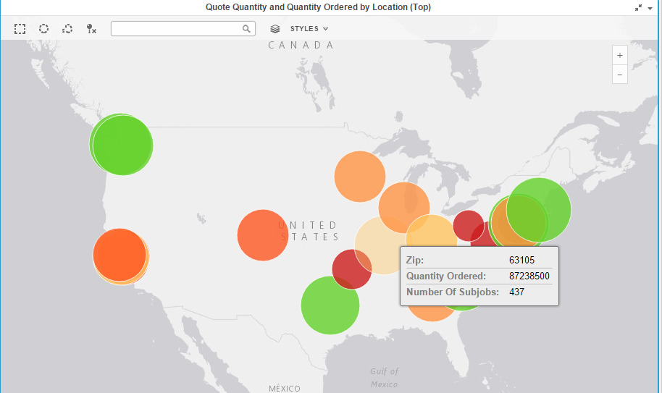

**Visualization - 2**

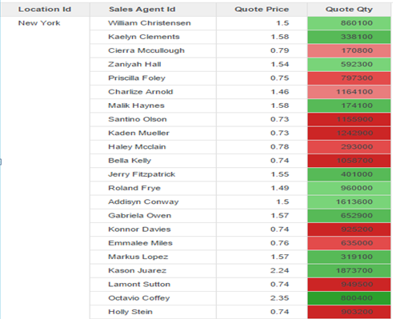

For each city, the color by quote quantity value, we can easily identify the agent with least quote value marked in red for each city or Location Id.

**Visualization - 3**

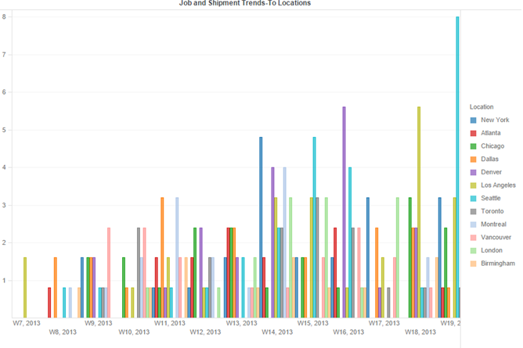

Base price values are not available by week for every location.Data is not update per week at each location.

**Visualization – 4**

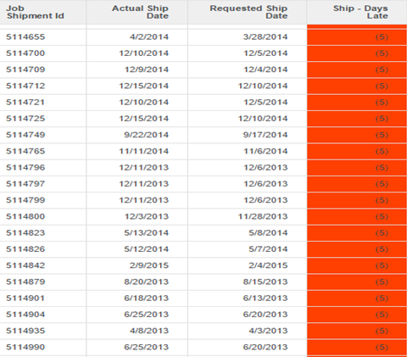

**Dashboard - 1 Results**

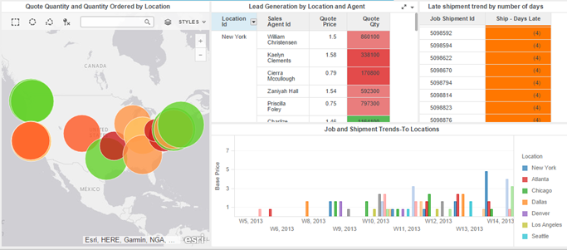

**Dashboard - 2**

**Visualization - 1**

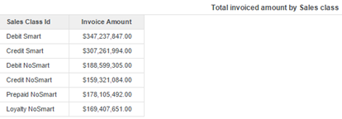

Above Chart shows the different invoice amounts for different sales classes.

**Visualization - 2**

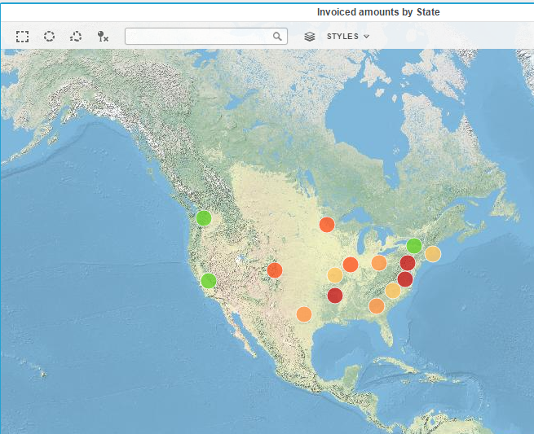

Above visualization shows the different states with invoice amounts shown by color. Marked in green are the states with highest invoice amounts and marked in red should the problem areas.

**Visualization - 3**

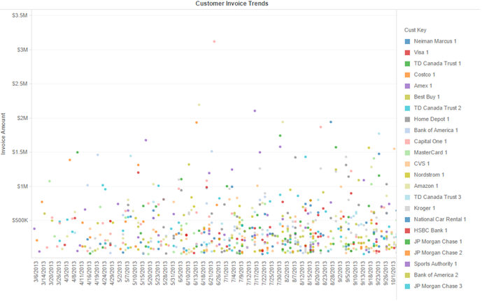

Above visualization shows the change in invoice amount for each customer over a period of time. This can help keep track of amount for each customer by invoice dates.

**Visualization - 4**

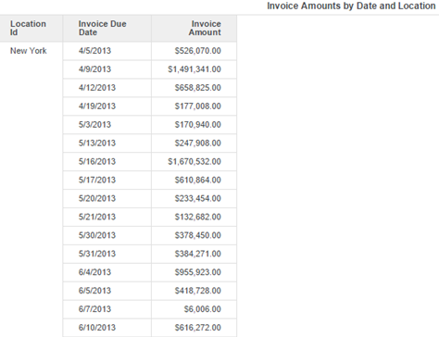

Above visualization shows the different locations with invoice due dates and amount.This can help us visualize the invoice amount about the due dates for different regions.

**Dashboard2 - Results**

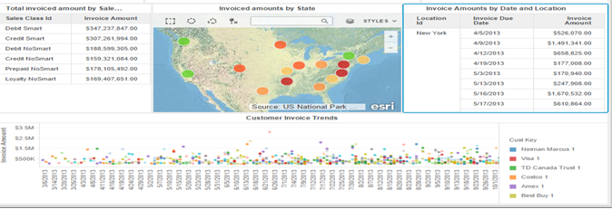

**Answers:**

Q1. Which sales class generate the highest invoice amounts? **Debit Smart**

Q2. How many invoices are generated for a time period?

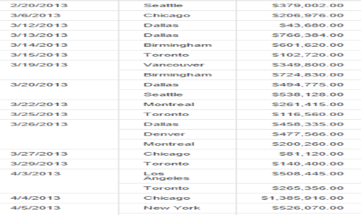

Above visualization can be easily made from grid table showing amounts by location and date.

Now for each date we can see the number of invoices.The date column can be changed to by month, by year to keep track of number of invoice by time.

**Dashboard - 3**

**Visualization - 1**

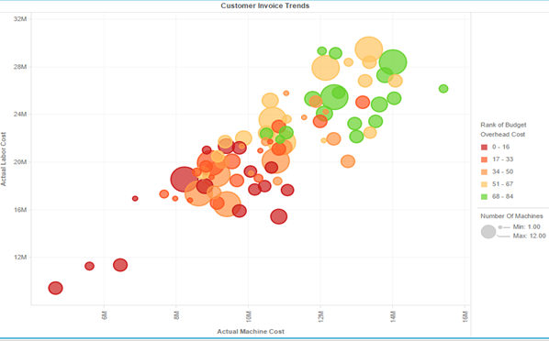

Above visualization shows the analysis of budget overhead cost compared to Labor and Machine

**Visualization - 2**

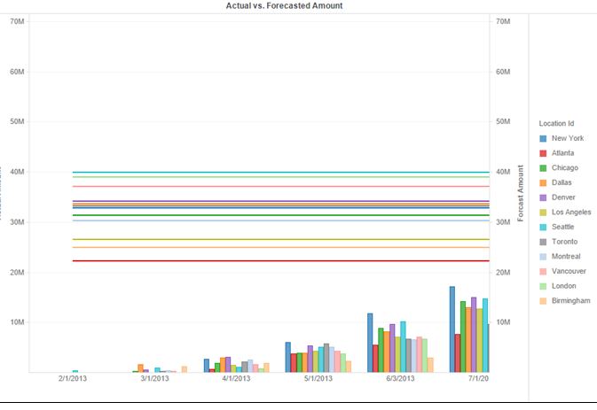

**Dashboard - 3 Results**

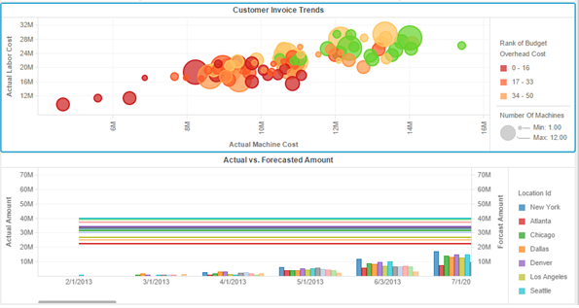

**Answers:**

* Determine the location and the machine which have the highest overall machine and labor cost. Also determine which location has the lowest budget overhead cost.

Highest Overall Actual Machine+Labor Cost = Seattle

Lowest Budget Overhead Cost = Atlanta $6838820.8

* Which location is seen to have higher forecast amount in comparison to the actual amount on the basis of time period?

Answer is Vacouver ($655,499,035) difference that is max between forecasted amount and Actual Amount

.